Summary
Paper Title | How do large multinational companies implement open innovation?
Paper Author | Letizia Mortara, Tim Minshall
Tags | Open innovation (OI), Open innovation implementation, Organizational change, Organizational culture, Case studies
Summary Conductor | Hannah Schulz

Key Takeaways
- Paper addresses a major gap in reported research on open innovation (OI): how do companies implement open innovation?
- The way firms adopted OI was found to vary according to (1) their innovation requirements, (2) the timing of the implementation and (3) their organizational culture.
- Innovation Needs: Difference in OI implementation when firm is looking for ambidexterity (in- and outbound) or only to support its current innovation pipelines (inbound)
- Timing of Implementation: Clear demarcation between firms that adopted OI as a result of the publication of the model and those who had established OI activities previous to it
- Organizational Culture: Despite the need for ambidexterity, firms with a strong tradition of closed innovation concentrated on inbound activities only

Paper Overview
Abstract and Introduction
- Paper addresses a major gap in reported research on open innovation (OI): how do companies implement open innovation?
- ‘Open innovation’ (OI) = Organizations make use of internal and external resources to drive their innovation processes
- Method:
  - Sample of 43 cross-sector firms were reviewed for their OI implementation approaches, using an inductive approach
  - Following the principles of ‘engaged scholarship’ case studies and focus groups were alternated in which practitioners discussed OI implementation. After that a taxonomical approach was adopted to analyze the path taken by firms as they moved from closed to open innovation practice
- On the basis of evidence from the sample, identification of 4 archetypical approaches to the adoption of OI:
  - ad-hoc practice
  - precursor OI adopters
  - OI conscious adopters
  - OI communities of practice.
- 2 key drivers for OI implementation:
  - Firms with less turbulent environments focus primarily on inbound OI activities,
  - Environmental uncertainty and the need for ambidexterity leads firms to develop both inbound and outbound activities
- Publicity regarding OI (many studies, articles, etc.) drives its implementation in firms

Literature review & research framework
2.1. OI is a widespread phenomenon
  - There are reasons for and barriers to the adoption of OI
- OI adoption could be a response to innovation impediments, such as lack of capability or information access and risk management
- Main reasons for outsourcing R&D (UK pharmaceutical companies) are accessing expertise not available in-house, reducing development time and cost, accessing technology competence and sharing risks
- NIH syndrome (Not-Invented-Here) most significant challenge for OI implementation
  - Two directions of knowledge flow: outside-in and inside-out
- For many company functions dealing with innovation (e.g. R&D, supply chain and marketing) OI equates mostly with the ‘outside-in’ process (i.e. exploration activities)
- Research highlights the importance of direct contacts between employees of different organizations as a way to increase the exploitation of internal ideas and technologies, companies typically set up separate functions, teams or individual roles specifically for the ‘inside-out’ process (e.g. ‘Intellectual-asset managers’)
  - Research framework
- Taxonomy of OI implementation to analyze our case studies, based on two key dimensions:
    - Organizational coordination of OI activities
    - Change impetus for the adoption of OI
Methodology
- Use of qualitative case study method
- 2 years of research (2007–2008) through three phases (A, B and C)
- This paper describes the integration of the results of the case studies, literature review and focus groups of all 3 stages, giving an overview of how companies currently implement OI
- Phase A—General issues for OI implementation
Development of appropriate culture and skills to enable the operation of an OI strategy is an area of significant interest
- Phase B—Culture for OI
Participants were asked to summarize the practices adopted in their organizations to support and enable the implementation of OI
- Phase C—Skills for OI
Theoretical framework was developed from literature to explain the skills required for practicing inbound OI by individuals in R&D and the other innovation functions
Results
- Mapped on onto the taxonomy developed in Fig. 1
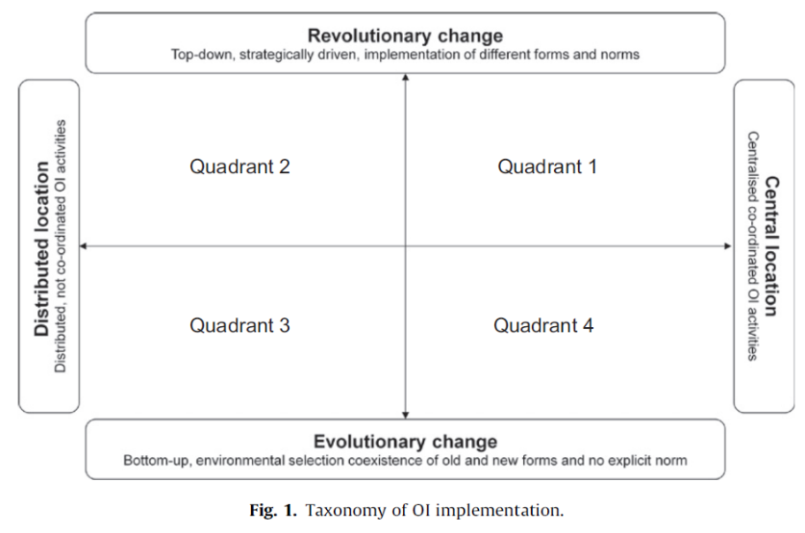
4.1. Q1: top-down/centralized—OI conscious adopters
OI adoption drivers | - Quadrant largely populated by FMCG companies who adopted OI as a result of popularity  - OI as opportunity to accelerate innovation and to promote growth in a sector where revolutionary innovation is very hard to achieve, competition is very high and market very demanding  - Costs have forced many firms to adopt an OI approach  - FMGC’s innovation strongly dominated by brands and adoption of OI contributes to the reinforcement of branding message  - Other examples of OI in this quadrant adopted OI as a result of a technology disruption
OI adoption timeframe | Quite tight around the publication of the OI original book (Chesbrough, 2003)
OI process | - Companies focused mainly on the inbound OI process
OI implementation features | - Small group of managers who were tasked to direct the implementation of OI

4.2. Q2: top-down/decentralized—OI ad-hoc adopters
OI adoption drivers | - Quadrant populated by firms that adopted OI only in certain functions, in part of the company or for specific products/innovation processes  - OI has become an interesting option as costs for R&D increase whilst available funding constantly diminishes  - Organizations in this quadrant aim to identify ways to bring in commercial off-the-shelf technologies (COTS), which could be inserted in open architectures
OI adoption timeframe | Varied
OI process | The prevailing OI process is ‘inbound’
OI implementation features | For these organizations, OI happens in particular circumstances (e.g. one project or function) but no coherent plan to roll out OI across the firm

4.3. Q3: bottom-up/decentralized—OI precursors
OI adoption drivers | - Adoption of OI progressively  - Firms in this quadrant have a very long history of integrating internal and external resources for innovation  - The transaction has happened in response to changes in their external environment  - In this field, significant innovation is not considered an option in the short term  - Firms are seeking breakthroughs to solve the difficult problems of the future by adopting an OI model
OI adoption timeframe | Adopting of OI throughout the business prior to the recent wave of interest in OI by progressively enabling their functions to access external resources
OI process | Activities for both inbound and outbound processes were observed
OI implementation features | - No central coordination of OI activities

4.4. Q4: bottom-up/centralized—OI communities of practice
OI adoption drivers | Innovation managers from R&D and Procurement functions are considering implementation of OI to meet difficult innovation targets
OI adoption timeframe | Recent adoption of OI as a conscious Innovation paradigm, although collaboration with suppliers and universities preceded this decision
OI process | - Focus: Inbound activities  - ‘New business’ team looking at niche opportunities, whilst for the outbound process occasional outlicensing of technology and brands are considered
OI implementation features | R&D and Procurement in partnership are leading the OI initial thinking
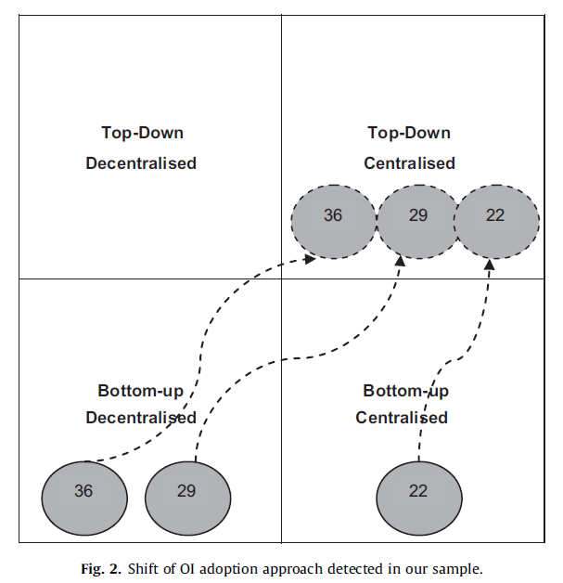
4.5. Shift in implementation approaches

Discussion
  - OI implementation: innovation drivers
- Approaches to implementation of OI activities:
  - Support current innovation activities aimed at core markets
  - Implementation as a result of the need for the ambidexterity of the firm
    - Inbound activities to fuel existing innovation pipelines
- Reasons outsourcing R&D: Reduce costs and increase access to competences and skills, fueling traditional innovation opportunities
- FMCG firms focus: Organizing OI practice to supplement innovation competencies and core innovation program, as discontinuous innovation is rare
    - In and outbound activities to pursue ambidexterity
- Several firms implementing OI to support innovation in fields beyond the core company business, as a means to achieve ambidexterity
- First adoption of open approaches to innovation several years before OI term was coined
Progressive transformation
- Changes towards openness often coincided with cost-driven R&D, business model reorganizations and change of management
  - OI implementation: timing
- ‘Success factors’ previously identified by the innovation implementation literature: communication, training, management buy-in, cross-functional teams and, in particular, reliance on champions and leaders to project and manage OI implementation
- When OI trend has been made explicit, implementation has been ‘perturbed and forced to fit’ the OI model
- Risk: forcing OI could potentially lead to a ‘lock-in’ situation.
  - Impacts of cultural internal and external contexts
Conclusion & Limitations
- The implementation path of OI was found to depend on (1) innovation needs, (2) the timing of the implementation and (3) the organizational culture

