Summary
Paper Title | Open Innovation Maturity Framework
Paper Author | Ellen Enkel, John Bell, Hannah Hogenkamp
Tags | Open innovation; metrics; excellence; maturity framework
Summary Conductor | Hannah Schulz

Key Takeaways
- Procter and Gamble discovered that open innovation projects outperform internal projects, achieving a 70% higher NPV (Net Present Value)
- 3 core elements of open innovation: partnership capacity, climate for innovation & visionary leadership, presence of the right systems and tools
- 5 maturity levels: initial/arbitrary, repeatable, defined, managed and optimizing
Framework assumes that maturity is a measure of the effectiveness of processes
- Measuring open innovation focuses mainly on measuring individual input or output factors rather than excellence in open innovation activities
- The developed tool could be used to evaluate a business unit or team or the whole organization when there is a consensus on the elements to be included

Paper Overview
- Main goal of paper: Develop an open innovation maturity framework to measure and benchmark excellence in open innovation (in collaboration with 15 companies)
- The developed open innovation maturity framework combines metrics in several areas of open innovation
Measuring the Effectiveness of Open Innovation
- Measuring innovation management can help to monitor and optimize innovation activities, but this is not always easy because results may not be clearly visible and the success of innovation projects may be uncertain or influenced by factors that cannot be controlled.
- The innovation process is increasingly being opened up to benefit from external resources.
- This use of external resources in R&D, an extension of the resource-based view , is referred to as open innovation.
- Approaches to Measurement:
  - Performance measurement essential due to influence on decision-making, motivating employees, stimulating learning, and improving coordination & communication
  - Most important factors when designing a measurement system are:
    - Deciding what to measure
    - Deciding how to measure it
    - Collecting the appropriate data
    - Eliminating conflicts within the measurement system
- The concept of maturity in measuring effectiveness:
  - Relationship btw. process quality improvements and organizational performance is not entirely straightforward but evidence for a positive correlation can be found in both literature on TQM (total quality mgmt.) and in dynamic capability literature
  - Maturity is one concept that has been used in software engineering to assess the effectiveness and development of a process
  - Maturity of a process/activity = extent to which a specific process is explicitly defined, managed, measured, controlled, and effective
  - Increasing maturity can be seen as the institutionalization of processes via policies, standards & organizational structures
  - More components of the process Process is more mature Greater capabilities
  - Capability Maturity Model (CMM): Assesses level of majority
  - Majurity in R&D: Quality & Maturity Method (QMM)
No systematic procedures (initial level Agreement on the approach to be taken (repeatable level) Documentation of the approach (defined level) Measurement of the approach (predictable level) Continuous improvement of the approach (optimizing level)
  - Closer to open innovation: Innovation Capability Maturity Model:
3-dimensional framework concerning innovation capability construct, organizational construct, and capability maturity
5 levels of maturity Focus only on internal R&D Not completely suited to measuring open innovation maturity
- Adapting the concept of maturity to open innovation:
  - Open innovation: High importance of partnership capacity
  - Creation of climate, conducive to innovation & visionary leadership essential for innovative activities
  - Availability of the right systems, tools and processes important enabler for open innovation initiatives
  - Framework assumes that maturity is a measure of the effectiveness of processes
  - Propositions:
    - The presence of partnership capacity correlates positively with the effectiveness of an organization’s open innovation activities
    - The creation of a climate for innovation is positively related to an organization’s open innovation effectiveness
    - Having the right systems and tools in place correlates positively to the effectiveness of open innovation
  - Combining these three core elements of open innovation with the five maturity levels (initial/arbitrary, repeatable, defined, managed and optimizing) give us a preliminary framework for open innovation maturity.
Method
- Exploratory research to develop a measurement framework for open innovation maturity
- Research involved interviews & workshops with innovation managers from 5 different companies, the collection of data from archives & high-tech organizations and workshops with ten companies to test and discuss the tool
- Development of excel tool that divided the three categories of climate for innovation, partnership capacity and internal process into ten closely related elements
Findings
- Companies found it hard to identify what constituted excellence
- The expectations implicit in our propositions were thus met, it became clear that the order of the three elements is also important. A climate for innovation should be the first ingredient that an organization develops, followed by partnership capacity and internal processes and tools
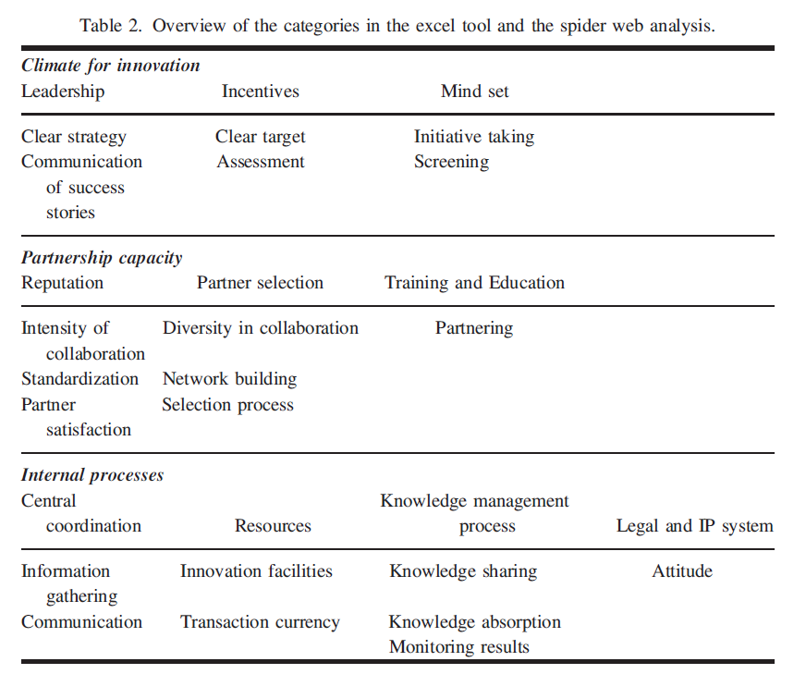
- Companies agreed with classification and found it to be an extremely helpful way of identifying individual areas of improvement as well as benchmarking their own open innovation efforts in relation to other major players from different sectors
- 3 examples: 3 companies representing the 3 categories of maturity
  - Food Com: An immature open innovation company
  - Research Com: A semi-mature open innovation company
  - TeleCom: A mature open innovation company

Discussion
- Based on the literature study, a preliminary framework was developed describing three main elements of open innovation maturity. This framework was based mainly on alliance mgmt., innovation mgmt. literature and on the work from software development
- The major managerial contribution lies in the translation of the table and concept into an easy-to-use excel tool
- Limitation of the tool: Definition of open innovation that focuses on using external partners in order to develop and introduce valuable ideas Exclusion of certain parts of the open innovation approach, such as spin-offs and location decisions
- Measuring open innovation focuses mainly on measuring individual input or output factors rather than excellence in open innovation activities
- The tool could be used to evaluate a business unit or team or the whole organization when there is a consensus on the elements to be included
- Excel Tool:
Calculates the profile automatically on the basis of the user’s answers and produces a spider web on the third page. The interpretation of the spider web diagram should be done in the team to identify areas for improvement and which results are already satisfactory to take care of company and sector-related individual factors.
- Limitations:
  - Results are not absolute figures
  - Company does not necessarily need or want to reach the highest level of maturity in each category
  - Interpretation of the levels differ according to the current status of open innovation, known open innovation activities in other companies as well as the progress achieved in recent years.
  - Without a common understanding of the questions, the tool will lead to inaccurate or sub-optimal results

