Summary
Not 100% relevant, very focused on embedded Linux & selective revealing
Paper Title | The emergence of openness: How and why firms adopt selective revealing in open innovation
Paper Author | Joachim Henkel, Simone Schöberl, Oliver Alexy
Tags | Open innovation, Open source software, Selective revealing, Embedded Linux, Multimethod studya
Summary Conductor | Hannah Schulz

Key Takeaways
- Open innovation is often facilitated by strong intellectual property rights (IPRs), but firms may benefit from voluntarily waiving some of their intellectual property rights (IPRs) in an open innovation process
- Research question: Why and how firms move from closed even IP-based open innovation, to open innovation embedding selective revealing, and maintain or extend this practice?
Study of the emergence of openness in the sense of selective revealing in subsectors of the computer components industry
- Analyzation of three aspects of selective revealing: (1) the way in which it is practiced, (2) its level, and (3) the change of this level overtime
- Results indicate that component makers went through a learning process, which led some to realize how selectively waiving IPRs may be beneficial for their business
- Customer demand pull = initial trigger & positive feedback loop sets in subsequently, leading to a further increase in the use of selective revealing

Paper Overview
Abstract & Introduction
- Open innovation is often facilitated by strong intellectual property rights (IPRs), but it may also function when firms deliberately waive some of their IPRs
- This paper conducts an empirical study in a segment of the computer component industry which traditionally has taken a rather proprietary stance
- With the advent of the open source operating system Linux, firms increasingly waived their IPRs on software drivers
- 2 means of maintaining exclusivity to innovation-related knowledge:
  - Secrecy
    - When practicing outbound or the “coupled” type of open innovation, the latter characterized by combining inflows and out-flows of knowledge, the innovator by definition gives up secrecy on the outbound knowledge
  - Legal exclusion rights
    - Often beneficial or even necessary for successful open innovation
- Firms may benefit from voluntarily waiving some of their intellectual property rights (IPRs) in an open innovation process
- While we have tremendously increased our understanding of open innovation and selective revealing, we still do not fully comprehend how closed firms move to open innovation in general, and to selective revealing in particular
- Research question: How and why do firms try out selective revealing in open innovation, and what determines if they subsequently maintain or even extend this engagement?
- Drivers are normally closed
- Increasingly articulated customer need for openness and ECMs’ experiences with openness over time initiated a positive feedback loop increasing average levels of selective revealing
- This process facilitated the emergence of openness not only as a phenomenon, but as a new dimension of competition
- 3 mechanisms: Demand pull, feedback loop, new competitive dimension
Background
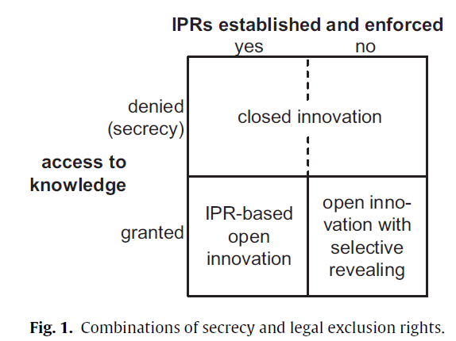
- Sharing knowledge across firm boundaries does not imply that the originator of this knowledge relinquishes ownership, but it has also been argued that strong IPRs are often beneficial and potentially even necessary for open innovation
- Innovators may benefit by sharing knowledge (and thus giving up secrecy) and waiving, or not establishing in the first place, legal exclusion rights to it = “free revealing”
- “Selective revealing” implies that the focal actor does not reveal out of principle but rather as a result of weighing the commercial pros and cons
- Innovator’s choices:
Benefits of selective revealing
  - Marketing Benefits: Positive effects on reputation, word-of-mouth-advertising, and increased opportunities to sell the product due to price reductions and increased customizability that are the results of selective revealing
  - Technical Benefits: Reduced production cost, increased reliability, the use of standard components, and access to new markets. Selective revealing might mitigate transaction cost (since no costly bilateral contracting happens) and decreases hold-up (since revealing is a credible and usually irreversible commitment).
- Risks of selective revealing
  - Imitation and loss of competitive advantage, reduced compatibility, reliability, safety and security, and increase in maintenance cost
Data & Methods
- With the advent of the Linux operating system and the development of variants particularly relevant to these industries (loosely called “Embedded Linux”) selective revealing has become increasingly important to ECMs
- Analyzation of three aspects of selective revealing: (1) the way in which it is practiced, (2) its level, and (3) the change of this level overtime
- Sequentially-ordered, mixed-methods research design
Qualitative Study
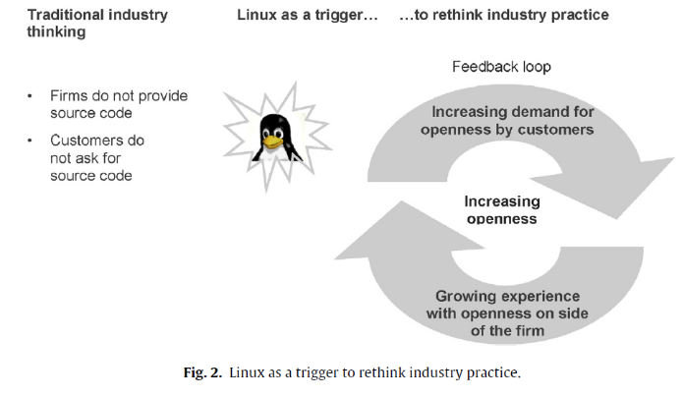
Quantitative Study
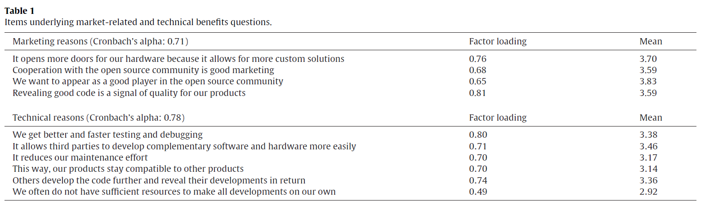
Discussion
- Analysis paints a fairly consistent picture of the emergence of selective revealing Enters the industry via customer demand, proliferates through positive feedback loops, and eventually becomes a new dimension of competition
- 3 contributions to the ongoing discussion on OI and selective revealing
  - Considerable external pressure may be required so that companies initiate such radical re-evaluations of how they create and capture value
    - External pressure in favor of selective revealing shifted the cost-benefit analysis preceding the decision to selectively reveal, literally over-writing concerns about risk and the power of inertia.
    - Underlying this pressure are the coupled dynamics of technological opportunity and market pull
  - Distinction between selective revealing by putting code on a website versus joining or launching a public OSS project that first emerged in our qualitative analysis allows us to gain further theoretical traction
    - Contributing code to a public OSS project or launching such a project facilitates open innovation in the sense of informal collaboration between the seller and the buyers, often resulting in considerable development support for the seller
    - The intensified interactions between customers and suppliers give rise to more meaningful relationships that resembled strategic alliances or other forms of “true partnerships.”
    - Different types of open innovation may not only feature operational, but also qualitative differences
- Findings raise the question under which circumstances open collaborative innovation, given it can be implemented, would be superior to a simple outbound process, and call upon future research to inquire this matter
  - Effects of selective revealing on competitive dynamics
    - Beyond price, quality and marketing, opennesse merged as a new dimension of competition in this market
    - Given increasing customer demand for openness, selective revealing has a positive effect on these firms’ competitive position vis-à-vis competitors that did not disclose their code

